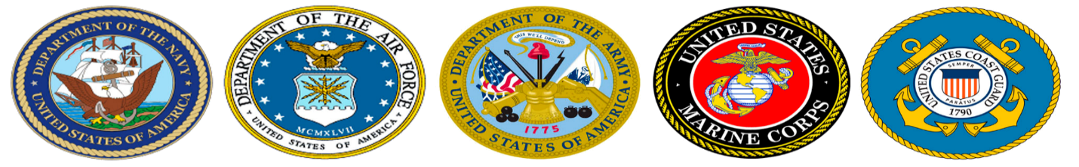

Veterans Club

Open to All Students

Are you looking to get involved? We are a new club on campus, and actively seeking members. If you like to help veterans, participate in the community projects or seeking student government positions. We are looking for you!
William Coleman
President
650-334-7319

